**SCOPE DOCUMENT**

**Landing Page**

* **Using the branded logo of Sanskara. (Attached below is the Sanskara logo)**

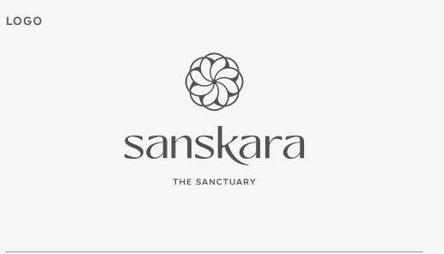

* **See the below Logo size scale, and follow the same.**

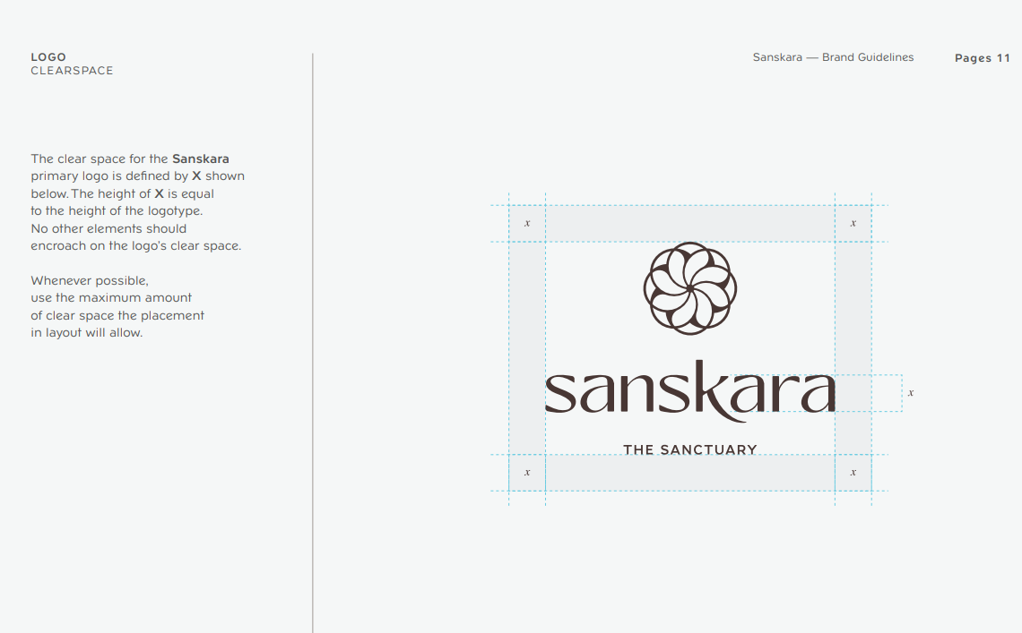

[**https://drive.google.com/file/d/10fQ0lzNLH9Ek-9SqQjUO4NyOES4qKVm0/view?usp=sharing**](https://drive.google.com/file/d/10fQ0lzNLH9Ek-9SqQjUO4NyOES4qKVm0/view?usp=sharing)

[**https://drive.google.com/file/d/1NWGSI1lIBwd9kCCDTC1mhnbnMgLulOuH/view?usp=sharing**](https://drive.google.com/file/d/1NWGSI1lIBwd9kCCDTC1mhnbnMgLulOuH/view?usp=sharing)

* **Follow the below logo adjustment pattern.**

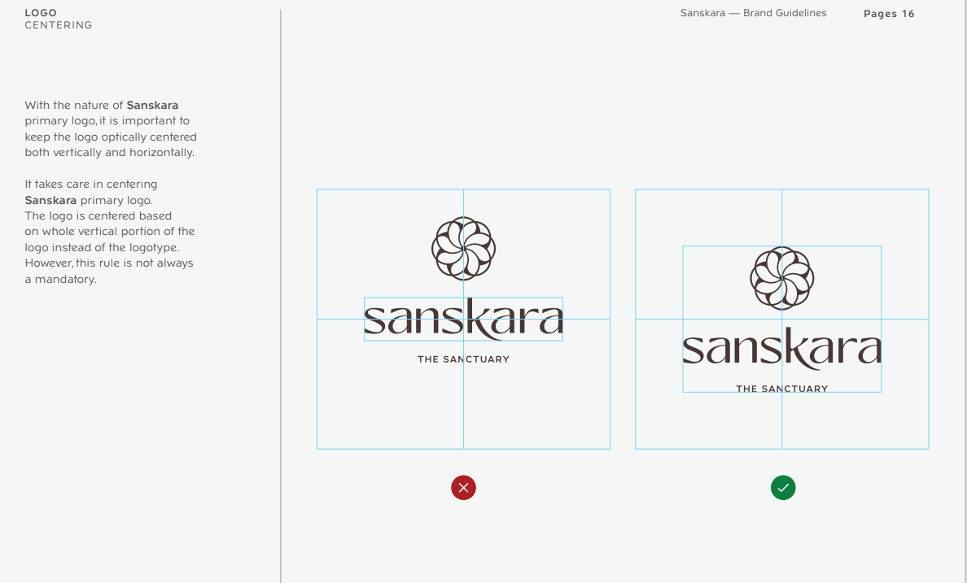

* **No of pages to view, only 2 slides pages, example:- Like Netflix Landing page something closer to their design but which will suit Sasnkara brand**

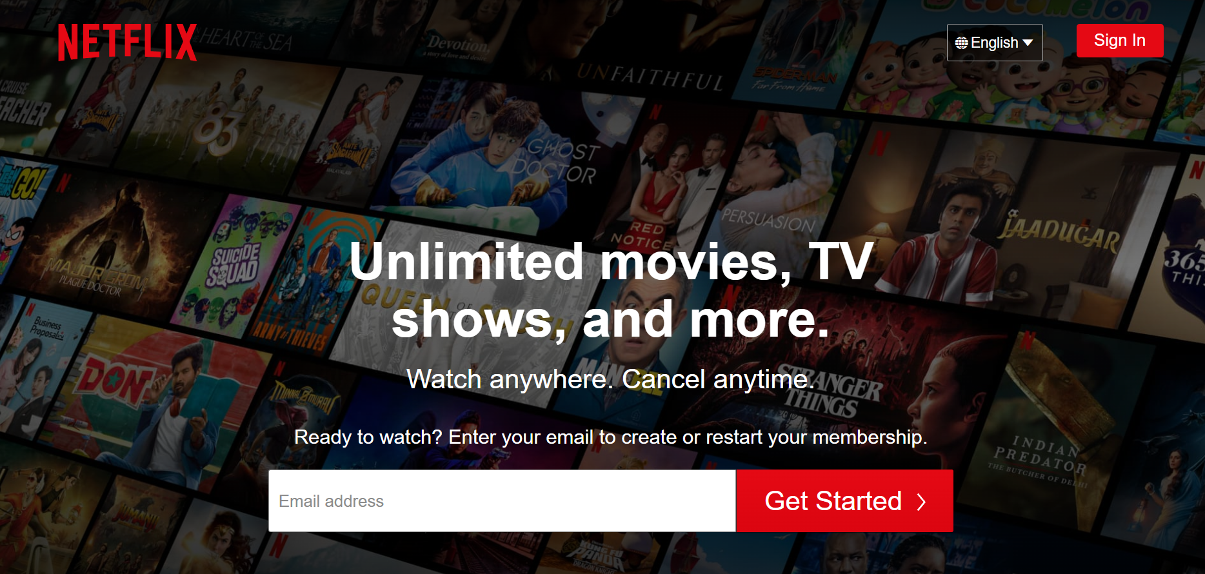

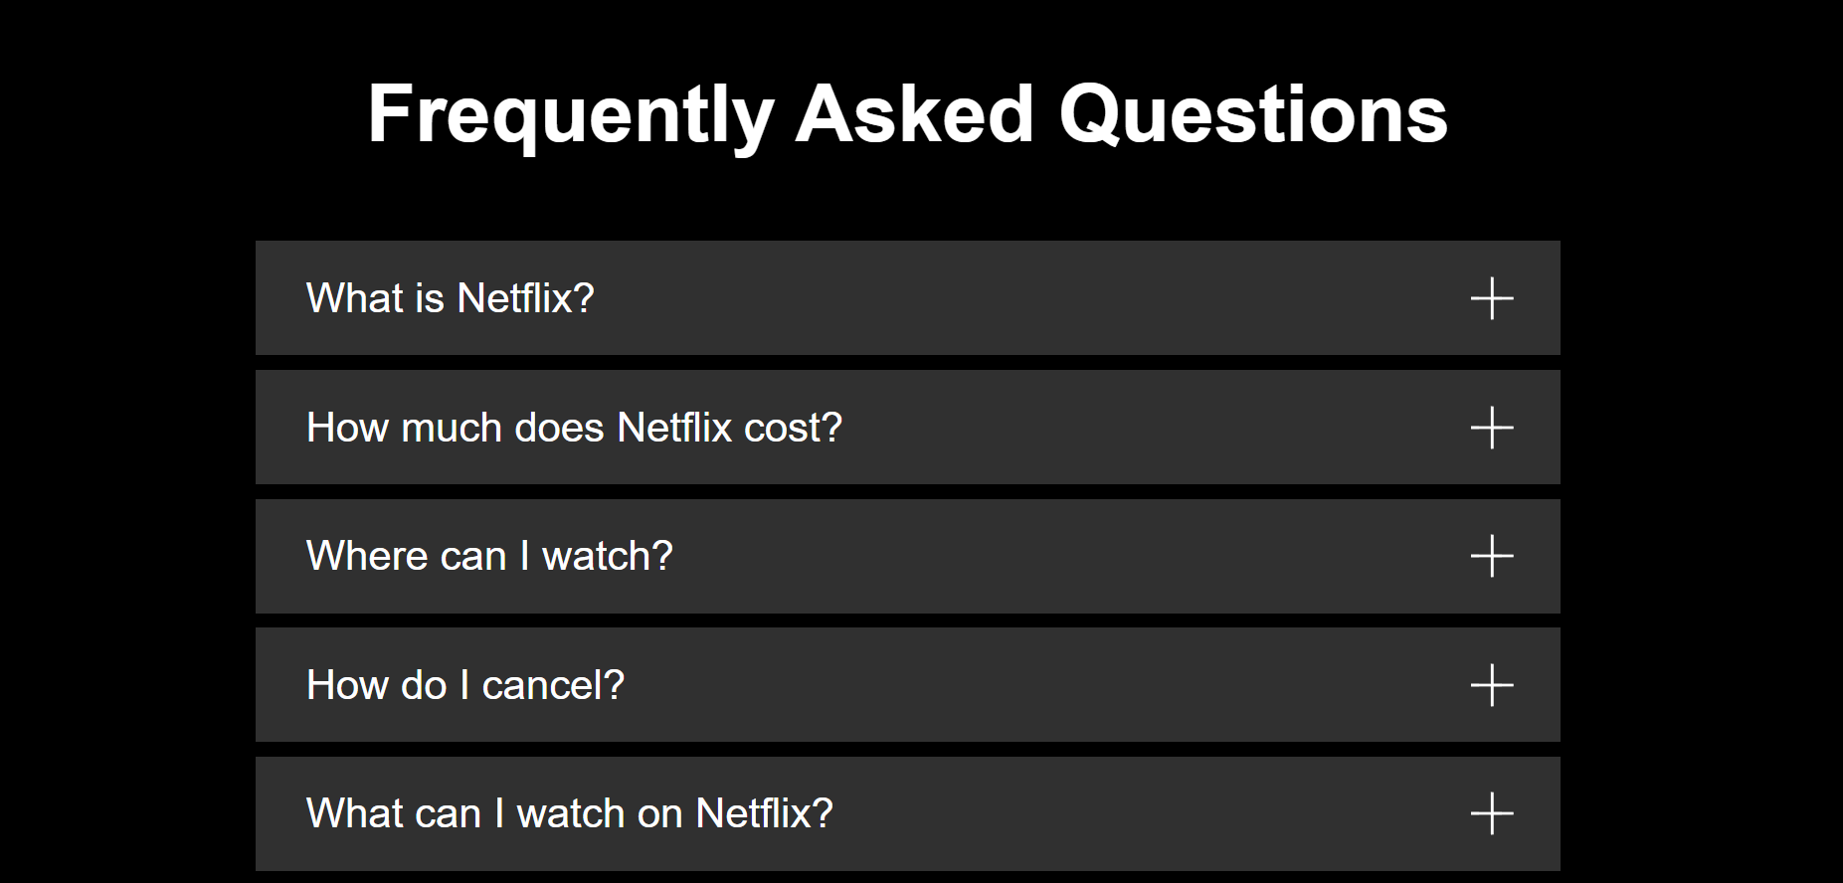

* **Sanskara Fonts mentioned in the brand guideline need to be used.**

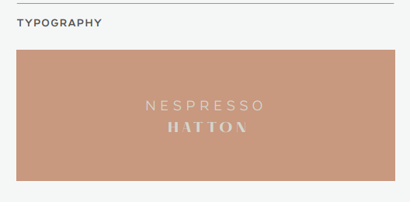

[**https://drive.google.com/drive/folders/1Sg64jx5dktWNYxAxf3nnlMBMj1m1iKMG?usp=sharing**](https://drive.google.com/drive/folders/1Sg64jx5dktWNYxAxf3nnlMBMj1m1iKMG?usp=sharing)

* **“Coming Soon” word needs to be shown off clearly and shown effectively**
* **Sanskara Animation video**

[**https://drive.google.com/file/d/16e7uAQkNr1Tq8Ljq55qDiYBSCttrX- sz/view?usp=sharing**](https://drive.google.com/file/d/16e7uAQkNr1Tq8Ljq55qDiYBSCttrX-%20%20%20%20%20%20%20sz/view?usp=sharing)

* **The below is the only colors that can be used in the landing page** 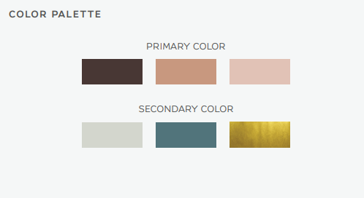

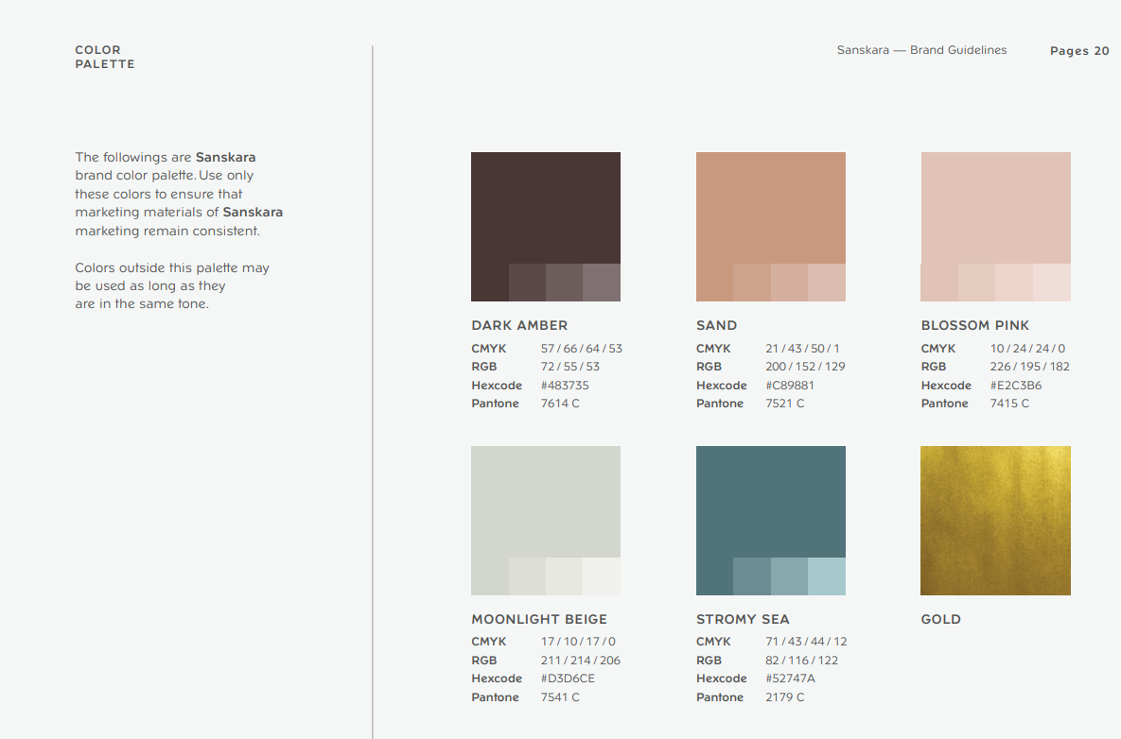

* **Sanskara Domain** [Sanskara Wellness – A Wellness Sanctuary](https://sanskara.com/)
* **About Sanskara on the landing page is a must.**
* **Subscribe, with Full name/ Mobile number / Email Address /**
* **Do not give away a lot of pictures of Sanskara in the background.**

[**https://drive.google.com/drive/folders/1o7PE8Qe5yudgae9CR-Cpk9OVa-JyaPb4?usp=sharing**](https://drive.google.com/drive/folders/1o7PE8Qe5yudgae9CR-Cpk9OVa-JyaPb4?usp=sharing)

* **Address & Location Pin:**Villa 1, Street 12A, Plot 357 - 546, Al Safa 2, Umm Al Sheif Road, Dubai, UAE
* <https://goo.gl/maps/VtddMzD22ro1DAyU8>
* **Opening hours Timings: 8 am – 11 pm**
* **Email Address:**[**connect@sanskara.com**](mailto:connect@sanskara.com)
* **Instagram account - @sanskaradxb**
* **Contact Number: (MOBILE) +971507742756**
* **Sanskara Wall carving image**

[**https://drive.google.com/file/d/1gvWha8e491NRl9A6S9z1sErhWNDuXbCu/view?usp=sharing**](https://drive.google.com/file/d/1gvWha8e491NRl9A6S9z1sErhWNDuXbCu/view?usp=sharing)

**Brief: Website Coming Soon Page for Sanskara:**

**I would like to design a high converting coming soon landing page to notify**

**Clients of our launch for Sanskara and build a relationship via email through**

**Mail Chimp.**

**The client need to sign up with their first name/last name/email address &amp;**

**Mobile number. This will automatically be sent to us in email for us to save in**

**Our database, but it should also get sent to mail chimp where they can get an**

**Automated welcome email.**

**WE CAN PROVIDE THE:**

**• Branding Guidelines with the logo &amp; Color:**

**• High Resolution Images of the Space.**

**• Sanskara Presentation: For you to learn more about the brand**

**The landing page should have: About Us: 2-3 Lines about us**

* **Sanskara is a wellness sanctuary, conscious eatery &amp; healing retreat**

**Surrounded by nature in the heart of Dubai.**

**Sanskara is not just another new business. It is Your Home Within.**

**It is a way of life. Curious to know more? Join our growing community. We promise… no chaos, only connection.**

**First Name:**

**Last Name:**

**Email Address:**

**Contact Number:**

**Social Media Icons**

**Instagram &amp; You Tube:**

**Instagram:** [**www.instagram.com/sanskaradxb**](https://d.docs.live.net/edc7ecb36469675f/Desktop/www.instagram.com/sanskaradxb)

**You Tube:**